Naineesh Reddy ALLURI
STUDENT ID:2198416
BSC COMPUTER SCIENCE
CIS:096-1
assignment
PRINCIPLES OF PROGRAMMING AND DATA STRUCTURES

Contents
INTRODUCTION: 1
Task description: 1
Functional requirements: 2
Nonfunctional Requirements: 2
Design: 3
USE CASE DIAGRAM: 3
ACTIVITY DIAGRAM: 4
ENTITY RELATIONSHIP DIAGRAM: 5
DATA DESIGN: 5
ENTITY RELATION MODEL: 5
THE ENTITIES: 6
PHYSICAL DATABASE DESIGN: 6
Choice of DBMS: 6
Data Dictionary: 7
USER INTERFACE DESIGN: 8
TESTING: 8
Discussion/Critical Reflection: 17
Conclusion: 17
Appendix: 17

INTRODUCTION:
In the digital age, efficient service management systems are critical for ensuring smooth interactions between service providers and users. This project focuses on creating a Service Management System (SMS) with a Java-based Graphical User Interface (GUI) designed for current service-based companies. Our SMS strives to improve service delivery by providing a user-friendly platform for engagement.
Our system is built on a meticulously developed GUI, which allows users to easily book, cancel, reschedule, and update service data. Powered by Java's adaptability, the GUI provides an easy user experience, allowing users to easily access services.
Key features include user authentication, account creation, and differential access for users and service providers. Integration with MySQL Workbench. enables effective data management by assuring the storage and retrieval of critical information from a centralized database.
This project demonstrates competency in software development techniques and object-oriented programming principles by offering a viable solution to real-world service management problems while adhering to industry standards and design best practices.

Task Description:
This project requires creating a Service Management System (SMS) with a Graphical User Interface (GUI) written in Java. The major goal is to provide a user-friendly platform that enables smooth interactions between service providers and users. The system should enable consumers to do critical operations such as booking, cancelling, and rescheduling services, while also allowing service providers to easily update service information. The interaction with the MySQL Workbench database is key to its functioning, allowing for extensive data management that includes the recording of user accounts, service details, and appointment scheduling. GUI design and implementation, database interface using JDBC, and user authentication procedures are all critical jobs. Thorough testing and debugging will guarantee that the system operates reliably in a variety of situations. Deliverables will be accompanied by detailed documentation, such as a user manual and a technical report. A presentation summarising the project's highlights and problems will be created for review.

Functional requirements:
The Service Management System (SMS) with Java GUI must enable users to safely establish accounts with vital data such as name, surname, email, username, and password, allowing for secure login in the future. Once signed in, users may explore services, examine information, and book, cancel, or reschedule appointments, with alerts sent to all parties involved. Service providers should manage service details such as updates and appointment scheduling.

Nonfunctional Requirements:
Data security is given top priority by the Java GUI-based SMS, which uses encryption to protect user data. With a growing user base, it is made to scale well and continue to function at its best. Platform independence guarantees smooth interaction between various systems. Its real-time responsiveness makes notifications and updates more rapid. Sturdy backup and recovery plans improve the system's resistance to any malfunctions. The GUI's intuitive design makes navigating simple for individuals with a range of technical skill levels. The system's extensibility and maintainability for further upgrades and improvements are ensured by compliance with industry standards and best practices.

Design:

USE CASE DIAGRAM:
The use case graphic depicts the interactions between actors and the Service Management System (SMS) using a Java GUI. Users and Service Providers are the major players, representing those who interact with the system. Users may use the diagram to create accounts, log in securely, browse services, book, cancel, or reschedule appointments. Service providers can update service information and manage appointment requests. These features let customers easily traverse the SMS, from account creation to appointment management, resulting in smooth service interactions. The diagram is a blueprint for system design, directing the deployment of features that fulfil user needs and improve usability. Furthermore, it improves stakeholder communication by outlining the system's functionality and behaviour straightforwardly and understandably.

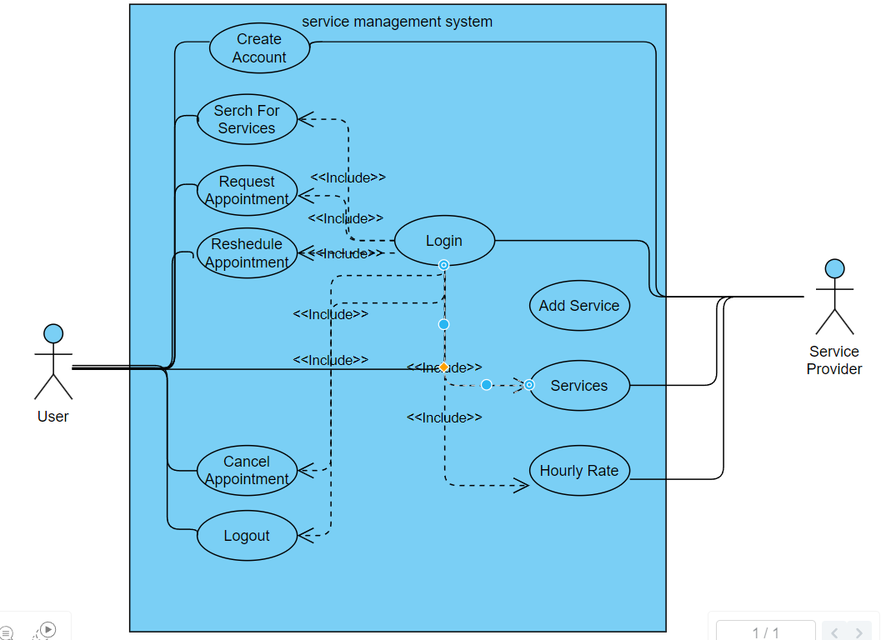

Figure 1: Use Case Diagram

ACTIVITY DIAGRAM:
The Activity Diagram for the Service Management System (SMS) in 100TP depicts the flow of activities inside the system, including the sequential stages involved in various user interactions. It describes the process of scheduling a service appointment, beginning with the user initiating the booking request and ending with the appointment confirmation. The figure displays steps such as user authentication, exploring available services, selecting a service, entering appointment information, and confirming the booking. It also contains error handling pathways for cases such as incorrect inputs or unsuccessful authentication. The Activity Diagram depicts the user path clearly, allowing for a better understanding of the system's behavior and interactions. It is a useful tool for system design, development, and testing, ensuring that the SMS runs smoothly and effectively to satisfy user demands.

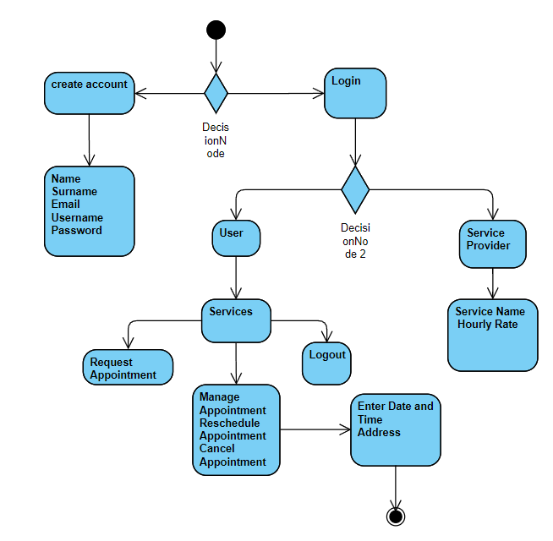
Figure 2: Activity Diagram.

ENTITY RELATIONSHIP DIAGRAM:

The Entity-Relationship Diagram (ERD) for the Service Management System (SMS) illustrates the entities, their attributes, and the relationships between them. Entities such as User, Service Provider, Service, and Appointment are represented, each with specific attributes capturing relevant information. Relationships such as one-to-many and many-to-many are depicted, reflecting how entities interact and associate with each other. For instance, a User can have multiple Appointments, while a service provider can offer multiple Services. The ERD provides a visual representation of the SMS's data model, facilitating an understanding of its structure and relationships, essential for database design and development.

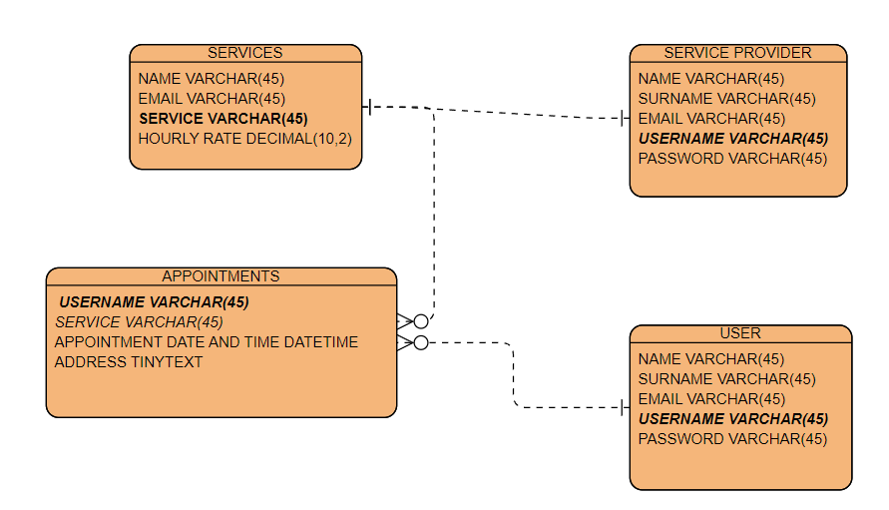
Figure 3: Entity Relationship Diagram

DATA DESIGN:
The SMS data architecture includes database tables such as User, Service Provider, Appointment, and Service, each with properties that capture crucial information. Table relationships are built using main and foreign keys, which ensure data integrity. restrictions such as unique and foreign key restrictions provide data consistency. This architecture facilitates efficient data storage and retrieval for critical system functions.

ENTITY RELATION MODEL:
The SMS entity-relationship model illustrates entities such as User, Service Provider, Appointment, and Service, with relationships built using main and foreign keys to ensure data integrity and effective data administration.

THE ENTITIES:

ENTITIES NAME | DETAILS ABOUT EACH ENTITY
User | Individuals using the system are represented by attributes such as their name, surname, email, login, and password.
Service Provider | Individuals or companies that provide services through the system are represented by characteristics like the User and may include extra data about service provision.
Service | Represents the services provided by service providers, including service name, description, and hourly rate.
Appointment | Represents appointments made by users for certain services, including features such as appointment date, time, and related user and service information.

PHYSICAL DATABASE DESIGN:

Choice of DBMS:

MySQL was chosen due to its dependability, ease of use, and worldwide popularity. MySQL, an open-source relational database management system (RDBMS), provides solid performance, scalability, and a diverse range of capabilities appropriate for this job. Its popularity provides considerable community support, documentation, and tools, making it accessible to developers of all skill levels. Furthermore, MySQL's interoperability with multiple operating systems and cost-effectiveness are in line with the project's objectives, making it a dependable and cost-effective alternative for database administration.

Data dictionary:
User Table:
username: VARCHAR (45), primary key
name: VARCHAR (45)
surname: VARCHAR (45)
email: VARCHAR (45)
password: VARCHAR (45)

Service provider Table:
username: VARCHAR (45), primary key
name: VARCHAR (45)
surname: VARCHAR (45)
email: VARCHAR (45)
password: VARCHAR (45)

Services Table:
service name: VARCHAR (45), primary key.
provider username: VARCHAR (45), foreign key (references service provider. username)
email: VARCHAR (45)
hourly rate: DECIMAL (10,2)

Appointments Table:
user username: VARCHAR (45), foreign key (references user. username)
service name: VARCHAR (45), foreign key (references services. Service name)
appointment date and time: DATETIME
address: TINYTEXT

SKELETON TABLE:
User Table:

Field | Data Type | Length | Index | Null | Default | Description
Username | VARCHAR | 45 | PK | No |  | Primary Key Unique identification of each user
Name | VARCHAR | 45 |  | No |  | First name of the user
Surname | VARCHAR | 45 |  | No |  | Last name of the user
Email | VARCHAR | 45 |  | No |  | Email address of the user
Password | VARCHAR | 45 |  | No |  | Password for user authentication

Service provider Table:

Field | Data Type | Length | Index | Null | Default | Description
Username | VARCHAR | 45 | PK | No |  | Primary Key Unique identification of each service provider
Name | VARCHAR | 45 |  | No |  | First name of the service provider
Surname | VARCHAR | 45 |  | No |  | Last name of the service provider
Email | VARCHAR | 45 |  | No |  | Email address of the service provider
Password | VARCHAR | 45 |  | No |  | Password for user authentication

Service Table:

Field | Data Type | Length | Index | Null | Default | Description
Service_name | VARCHAR | 45 | PK | No |  | Primary Key Unique identification of each service
Providers_username | VARCHAR | 45 |  | No |  | Foreign key referencing service provider username
Email | VARCHAR | 45 |  | No |  | Email address of the service provider
Hourly rate | VARCHAR | 45 |  | No |  | Hourly rate charged for the service

Appointment Table:

Field | Data Type | Length | Index | Null | Default | Description
User_username | VARCHAR | 45 | FK | No |  | Foreign key referencing user username
Service_name | VARCHAR | 45 | FK | No |  | Foreign key referencing service name
Appointment_datetime | DATETIME |  |  | No |  | Dare and time of the appointment
Address | TINY TEXT |  |  | No |  | Address for the appointment

USER INTERFACE DESIGN:

The user interface (UI) design for the Java-based Service Management System (SMS) involves designing a visually appealing and intuitive interface with Java Swing components. The user interface (UI) should represent the system's functionality, allowing users to simply explore and interact with the program. Text fields and buttons are important UI components for user authentication, account creation, service booking, appointment management, and service provider modifications.
The design should prioritize usability and accessibility so that consumers can easily learn how to log in, create accounts, book services, and manage appointments. Clear labeling, a uniform layout, and useful feedback messages all improve the user experience. Furthermore, including error handling systems and validation checks helps to prevent user mistakes and assures data integrity.
Overall, the UI design strives to create a smooth and efficient user experience, allowing customers to efficiently use SMS functions to schedule and manage services.

TESTING:
Test No:1

Purpose of the test: Ensure that users can create new accounts.

Expected result: After completing the registration form and selecting the Create Account button, the system should save the user's information to the database.

Actual result: The user completes the registration form, hits Create Account, and their information is recorded in the database.
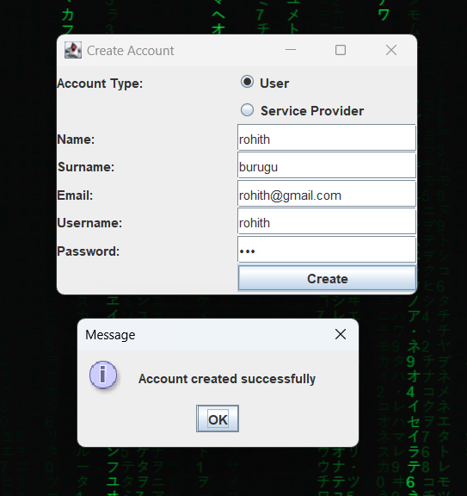
Figure 4: creating the user account.
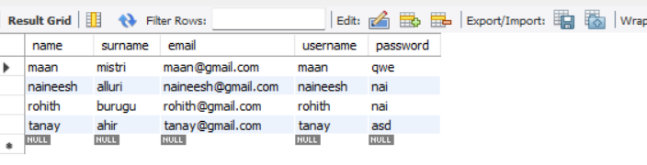
Figure 5: Data saved in the database.

Test No:2
Purpose: Ensure that users may successfully log in.
Expected Result: After providing the correct credentials and clicking the login button, the system should authenticate the user and take them to their dashboard.
Actual Result: The user inputs the correct credentials, clicks login, and is sent to their dashboard.
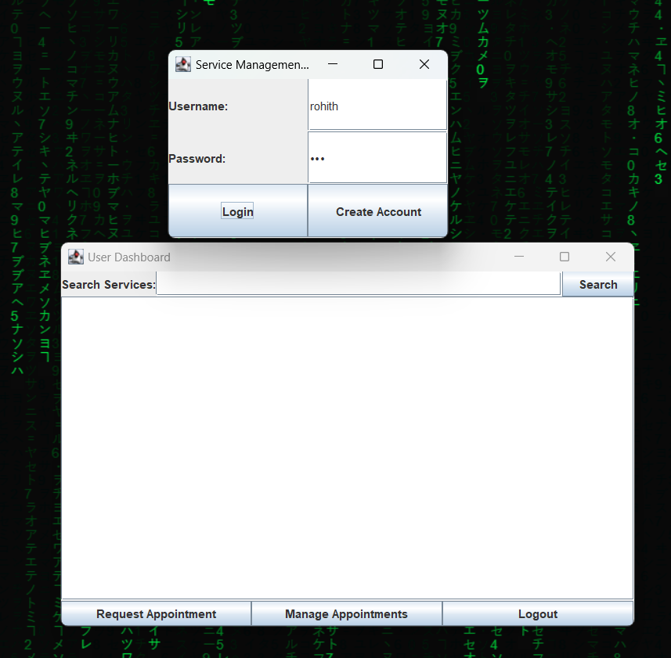
Figure 6: Open the user panel after providing the correct credentials.

Test No:3
Purpose: Allow users to book services.
Expected Result: After selecting a service, day, time, and address and pressing the book button, the system should generate a new appointment for the user.
Actual Result: The user picks a service, day, time, and address, then clicks book to make a new appointment.
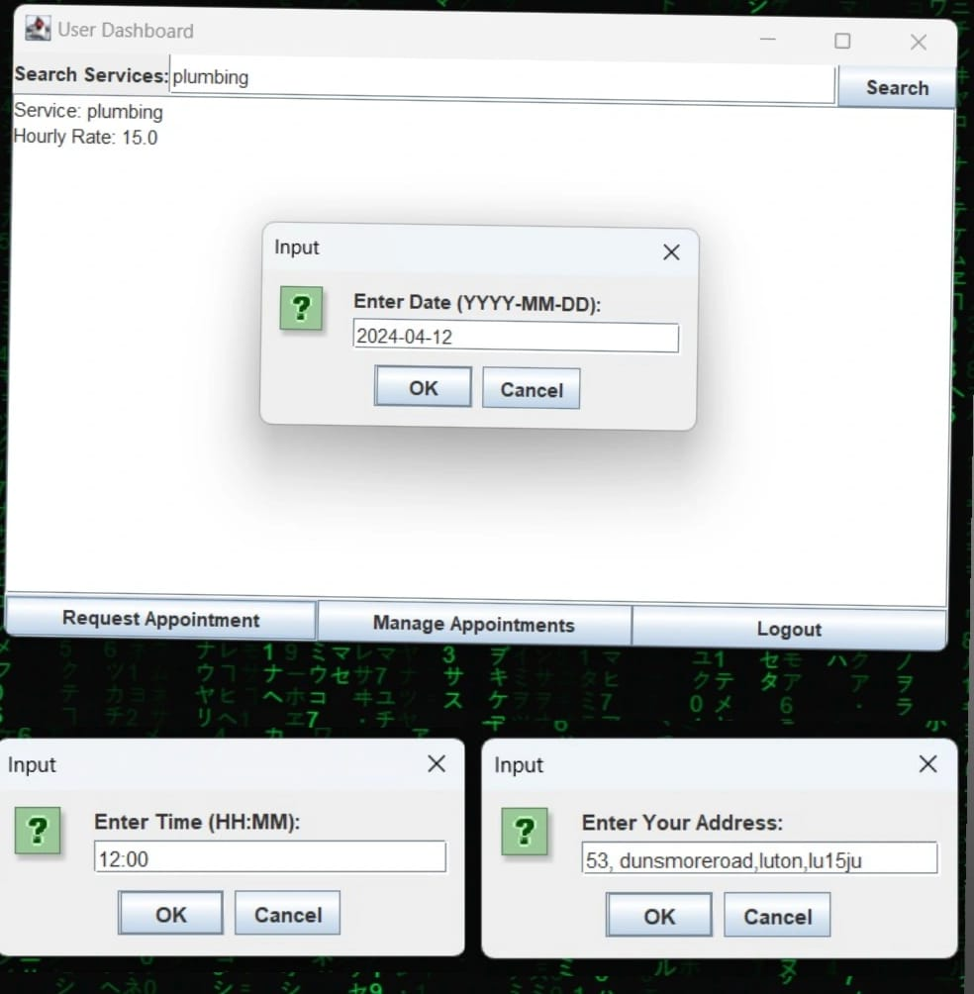
Figure 7: Booking services by giving the required information.

Test No:4
Purpose: Ensure consumers may reschedule appointments.
Expected Outcome: After choosing an appointment, entering a new date and time, and clicking the reschedule button, the system should change the appointment date and time in the database.
Actual Result: The user picks an appointment, enters a new date and time, and clicks reschedule, which updates the appointment's date and time in the database.

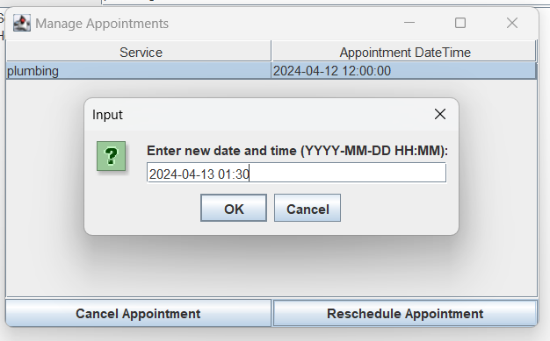

Figure 8: Rescheduling the appointment.

Test No:5
Purpose: Ensure consumers may cancel appointments.

Expected Result: After picking an appointment and pressing the cancel button, the system should delete it from the database.
Actual Result: After selecting an appointment, the user clicks cancel, and the appointment is erased from the database.

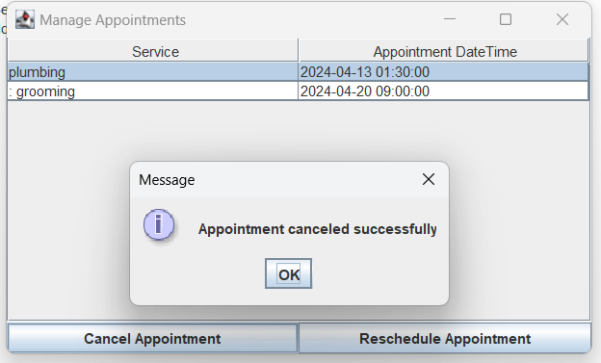

Figure 9: Cancelling the appointment.

Test No:6
Purpose: Allow service providers to create new accounts.
Expected Result: After completing the registration form and selecting the Create Account button, the system should save the service provider's information to the database.
Actual Result: The service provider completes the registration form, clicks Create Account, and their information is recorded in the database.
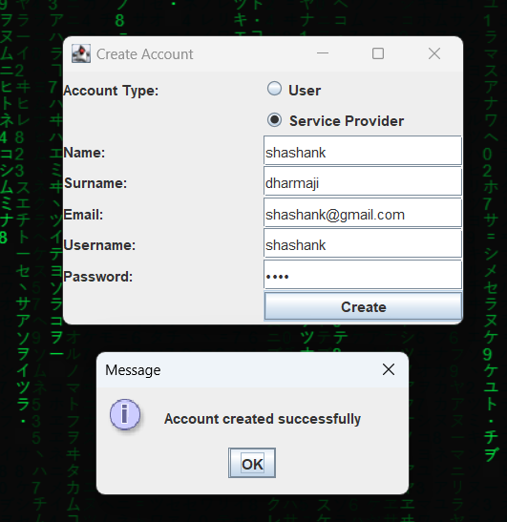
Figure 10: Service provider account is created.
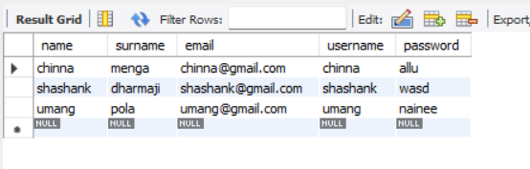
Figure 11: Data saved to the database after creating an account.
Test No:7
Purpose: Ensure that service providers may successfully log in.
Expected Result: After providing the correct credentials and clicking the login button, the system should authenticate the service provider and take them to their dashboard. Actual Result: The service provider inputs the correct credentials, clicks login, and is sent to their dashboard.
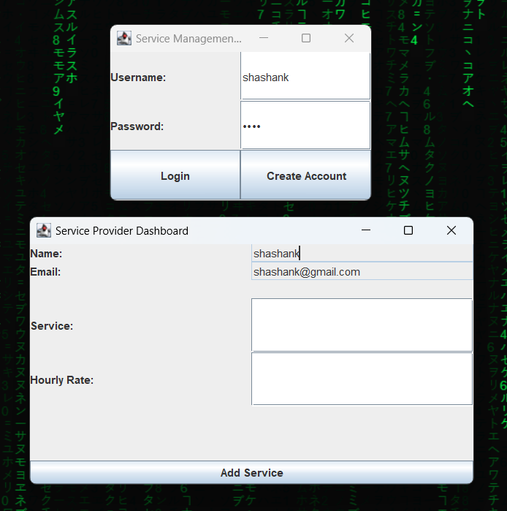
Figure 12: Opened the service provider dashboard after giving the correct credentials.

Test No:8
Purpose: Allow service providers to introduce new services.
Expected Result: After entering the service details, and hourly pay, and pressing the add service button, the system should save the new service information to the database.
Actual Result: The service provider enters the service details, and hourly pay and clicks Add Service, and the new service information is stored in the database.
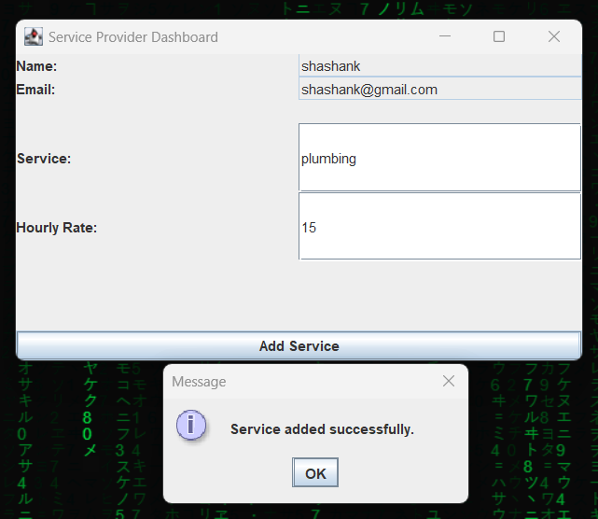
Figure 13: Service provider adding services.
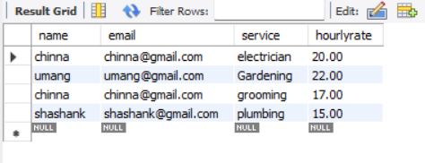
Figure 14: Services added to the database.

Discussion/Critical Reflection:
The Service Management System (SMS) assignment effectively implements essential functionality such as user authentication and appointment booking, utilizing Java Swing for the GUI and MySQL Workbench for database integration. While the UI design correctly captures entity connections, it might be improved for a better user experience by using clearer labeling and navigation. Scalability and extensibility considerations are critical for accommodating future expansions, with a focus on codebase modularity and flexibility. Quality assurance efforts, such as extensive testing, assure system reliability. Future iterations might include user feedback methods and more complex capabilities, such as payment processing integration. Overall, while the existing SMS implementation satisfies its objectives, more modification is required to improve usability, scalability, and user happiness, ensuring the system's relevance and effectiveness in supporting service management.

Conclusion:
Finally, the Service Management System (SMS) project provided great learning opportunities in software development, database integration, and user interface design. I've learned how to construct interactive apps using Java Swing and integrate them with MySQL Workbench for database operations by implementing essential functionality, including user authentication,
No table of figure entries found.
No index entries were found.
appointment booking, and service provider management. While the assignment accomplished its initial goals, there is always potential for improvement in terms of UI refinement, scalability, and feature growth. Moving ahead, I plan to apply the lessons I've gained from this project to future endeavors, always honing my abilities and striving for greatness in software development. Overall, the SMS assignment has been a wonderful experience that has increased my grasp of software engineering fundamentals and laid a good foundation for future, more difficult projects.

Appendix:

import javax.swing.table.DefaultTableModel;
import javax.swing.*;
import java.awt.*;
import java.awt.event.*;
import java.sql.*;

public class Main extends JFrame {
// GUI components
private final JTextField usernameField;
private final JPasswordField passwordField;
private Connection connection;

public Main() {
// Set up the GUI
setTitle("Service Management System");
setSize(300, 200);
setDefaultCloseOperation(JFrame.EXIT_ON_CLOSE);
setLayout(new GridLayout(3, 2));

JLabel usernameLabel = new JLabel("Username:");
JLabel passwordLabel = new JLabel("Password:");
usernameField = new JTextField();
passwordField = new JPasswordField();
JButton loginButton = new JButton("Login");
JButton createAccountButton = new JButton("Create Account");

// Add components to the frame
add(usernameLabel);
add(usernameField);
add(passwordLabel);
add(passwordField);
add(loginButton);
add(createAccountButton);

// Connect to the database
try {
// Establish database connection
connection = DriverManager.getConnection("jdbc:mysql://127.0.0.1:3306/servicemanagement", "root", "alluri1693");
} catch (SQLException ex) {
ex.printStackTrace();
}

// Event listeners
loginButton.addActionListener(new ActionListener() {
public void actionPerformed(ActionEvent e) {
login();
}
});

createAccountButton.addActionListener(new ActionListener() {
public void actionPerformed(ActionEvent e) {
createAccountWindow();
}
});

setVisible(true);
}

// Method to handle login
protected void login() {
String username = usernameField.getText();
String password = new String(passwordField.getPassword());

try {
// Check in user table
String userQuery = "SELECT * FROM user WHERE username=? AND password=?";
PreparedStatement userStatement = connection.prepareStatement(userQuery);
userStatement.setString(1, username);
userStatement.setString(2, password);
ResultSet userResultSet = userStatement.executeQuery();

// Check in serviceprovider table
String serviceProviderQuery = "SELECT * FROM serviceprovider WHERE username=? AND password=?";
PreparedStatement serviceProviderStatement = connection.prepareStatement(serviceProviderQuery);
serviceProviderStatement.setString(1, username);
serviceProviderStatement.setString(2, password);
ResultSet serviceProviderResultSet = serviceProviderStatement.executeQuery();

if (userResultSet.next()) {
// Retrieve user data from the result set
String name = userResultSet.getString("name");
String surname = userResultSet.getString("surname");
String email = userResultSet.getString("email");

// Display user information
JOptionPane.showMessageDialog(this, "User Login successful\nName: " + name + "\nSurname: " + surname + "\nEmail: " + email);

// Open user dashboard
userDashboard(username); // Pass 'username' to the user dashboard method
} else if (serviceProviderResultSet.next()) {
// Retrieve service provider data from the result set
String name = serviceProviderResultSet.getString("name");
String surname = serviceProviderResultSet.getString("surname");
String email = serviceProviderResultSet.getString("email");

// Display service provider information
JOptionPane.showMessageDialog(this, "Service Provider Login successful\nName: " + name + "\nSurname: " + surname + "\nEmail: " + email);

// Open service provider dashboard
serviceProviderDashboard(username, name, email);
} else {
JOptionPane.showMessageDialog(this, "Invalid username or password");
}
} catch (SQLException ex) {
ex.printStackTrace();
}
}

// Method to create the account window
private void createAccountWindow() {
JFrame accountFrame = new JFrame("Create Account");
accountFrame.setSize(350, 250);
accountFrame.setDefaultCloseOperation(JFrame.DISPOSE_ON_CLOSE);
accountFrame.setLayout(new GridLayout(8, 2));

JLabel typeLabel = new JLabel("Account Type:");
JRadioButton userRadioButton = new JRadioButton("User");
JRadioButton serviceProviderRadioButton = new JRadioButton("Service Provider");
ButtonGroup buttonGroup = new ButtonGroup();
buttonGroup.add(userRadioButton);
buttonGroup.add(serviceProviderRadioButton);

JLabel nameLabel = new JLabel("Name:");
JTextField nameField = new JTextField();
JLabel surnameLabel = new JLabel("Surname:");
JTextField surnameField = new JTextField();
JLabel emailLabel = new JLabel("Email:");
JTextField emailField = new JTextField();
JLabel usernameLabel = new JLabel("Username:");
JTextField newUsernameField = new JTextField();
JLabel passwordLabel = new JLabel("Password:");
JPasswordField newPasswordField = new JPasswordField();
JButton createButton = new JButton("Create");

// Add components to the account frame
accountFrame.add(typeLabel);
accountFrame.add(userRadioButton);
accountFrame.add(new JLabel()); // Empty label for spacing
accountFrame.add(serviceProviderRadioButton);
accountFrame.add(nameLabel);
accountFrame.add(nameField);
accountFrame.add(surnameLabel);
accountFrame.add(surnameField);
accountFrame.add(emailLabel);
accountFrame.add(emailField);
accountFrame.add(usernameLabel);
accountFrame.add(newUsernameField);
accountFrame.add(passwordLabel);
accountFrame.add(newPasswordField);
accountFrame.add(new JLabel()); // Empty label for spacing
accountFrame.add(createButton);

createButton.addActionListener(new ActionListener() {
public void actionPerformed(ActionEvent e) {
// Retrieve input values
String name = nameField.getText();
String surname = surnameField.getText();
String email = emailField.getText();
String newUsername = newUsernameField.getText();
String newPassword = new String(newPasswordField.getPassword());
String accountType = userRadioButton.isSelected() ? "User" : "Service Provider";

// Determine which table to insert data into
String tableName = (accountType.equals("User")) ? "user" : "serviceprovider";

// Save the new account details to the appropriate table
try {
String query = "INSERT INTO " + tableName + " (name, surname, email, username, password) VALUES (?, ?, ?, ?, ?)";
PreparedStatement preparedStatement = connection.prepareStatement(query);
preparedStatement.setString(1, name);
preparedStatement.setString(2, surname);
preparedStatement.setString(3, email);
preparedStatement.setString(4, newUsername);
preparedStatement.setString(5, newPassword);

int rowsAffected = preparedStatement.executeUpdate();
if (rowsAffected > 0) {
JOptionPane.showMessageDialog(accountFrame, "Account created successfully");
accountFrame.dispose(); // Close the account creation window
} else {
JOptionPane.showMessageDialog(accountFrame, "Failed to create account");
}
} catch (SQLException ex) {
ex.printStackTrace();
JOptionPane.showMessageDialog(accountFrame, "Failed to create account: " + ex.getMessage());
}
}
});
accountFrame.setVisible(true);
}

// Method to create the service provider dashboard
private void serviceProviderDashboard(String serviceProviderUsername, String serviceProviderName, String serviceProviderEmail) {
JFrame dashboardFrame = new JFrame("Service Provider Dashboard");
dashboardFrame.setSize(500, 300);
dashboardFrame.setDefaultCloseOperation(JFrame.DISPOSE_ON_CLOSE);
dashboardFrame.setLayout(new BorderLayout());

// Components for service provider details
JPanel providerDetailsPanel = new JPanel(new GridLayout(3, 2));
JLabel nameLabel = new JLabel("Name:");
JTextField nameField = new JTextField(serviceProviderName); // Set the name from the parameter
nameField.setEditable(false); // Make it non-editable
JLabel emailLabel = new JLabel("Email:");
JTextField emailField = new JTextField(serviceProviderEmail); // Set the email from the parameter
emailField.setEditable(false); // Make it non-editable
providerDetailsPanel.add(nameLabel);
providerDetailsPanel.add(nameField);
providerDetailsPanel.add(emailLabel);
providerDetailsPanel.add(emailField);

// Components for service details
JPanel serviceDetailsPanel = new JPanel(new GridLayout(3, 2));
JLabel serviceNameLabel = new JLabel("Service:");
JTextField serviceNameField = new JTextField();
JLabel hourlyRateLabel = new JLabel("Hourly Rate:");
JTextField hourlyRateField = new JTextField();
serviceDetailsPanel.add(serviceNameLabel);
serviceDetailsPanel.add(serviceNameField);
serviceDetailsPanel.add(hourlyRateLabel);
serviceDetailsPanel.add(hourlyRateField);

// Button to add service
JButton addServiceButton = new JButton("Add Service");

// Add components to the dashboard frame
dashboardFrame.add(providerDetailsPanel, BorderLayout.NORTH);
dashboardFrame.add(serviceDetailsPanel, BorderLayout.CENTER);
dashboardFrame.add(addServiceButton, BorderLayout.SOUTH);

// Event listener for adding a service
addServiceButton.addActionListener(new ActionListener() {
public void actionPerformed(ActionEvent e) {
String serviceName = serviceNameField.getText();
String hourlyRateStr = hourlyRateField.getText();

// Validate input
if (serviceName.isEmpty() || hourlyRateStr.isEmpty()) {
JOptionPane.showMessageDialog(dashboardFrame, "Please enter service name and hourly rate.");
return;
}

try {
double hourlyRate = Double.parseDouble(hourlyRateStr);

// Insert service into database
String insertServiceQuery = "INSERT INTO services (name, email, service, hourlyrate) VALUES (?, ?, ?, ?)";
PreparedStatement insertServiceStatement = connection.prepareStatement(insertServiceQuery);
insertServiceStatement.setString(1, serviceProviderName); // Use the parameter
insertServiceStatement.setString(2, serviceProviderEmail); // Use the parameter
insertServiceStatement.setString(3, serviceName);
insertServiceStatement.setDouble(4, hourlyRate);
int rowsAffected = insertServiceStatement.executeUpdate();

if (rowsAffected > 0) {
JOptionPane.showMessageDialog(dashboardFrame, "Service added successfully.");
} else {
JOptionPane.showMessageDialog(dashboardFrame, "Failed to add service.");
}
} catch (NumberFormatException ex) {
JOptionPane.showMessageDialog(dashboardFrame, "Invalid hourly rate format.");
} catch (SQLException ex) {
ex.printStackTrace();
JOptionPane.showMessageDialog(dashboardFrame, "Error: " + ex.getMessage());
}
}
});

// Display the dashboard
dashboardFrame.setVisible(true);
}

// Method to create the user dashboard
private void userDashboard(String username) {
JFrame userFrame = new JFrame("User Dashboard");
userFrame.setSize(600, 400);
userFrame.setDefaultCloseOperation(JFrame.DISPOSE_ON_CLOSE);
userFrame.setLayout(new BorderLayout());

// Components for search
JLabel searchLabel = new JLabel("Search Services:");
JTextField searchField = new JTextField();
JButton searchButton = new JButton("Search");

// Component for displaying search results
JTextArea searchResultsTextArea = new JTextArea();
searchResultsTextArea.setEditable(false);
JScrollPane searchResultsScrollPane = new JScrollPane(searchResultsTextArea);

// Fetch available services from the database
searchButton.addActionListener(new ActionListener() {
public void actionPerformed(ActionEvent e) {
String searchTerm = searchField.getText().trim();

if (!searchTerm.isEmpty()) {
try {
String query = "SELECT * FROM services WHERE service LIKE ?";
PreparedStatement preparedStatement = connection.prepareStatement(query);
preparedStatement.setString(1, "%" + searchTerm + "%");
ResultSet resultSet = preparedStatement.executeQuery();

searchResultsTextArea.setText(""); // Clear previous search results

while (resultSet.next()) {
String serviceName = resultSet.getString("service");
double hourlyRate = resultSet.getDouble("hourlyrate");

searchResultsTextArea.append("Service: " + serviceName + "\n");
searchResultsTextArea.append("Hourly Rate: " + hourlyRate + "\n\n");
}
} catch (SQLException ex) {
ex.printStackTrace();
JOptionPane.showMessageDialog(userFrame, "Failed to search services: " + ex.getMessage());
}
} else {
JOptionPane.showMessageDialog(userFrame, "Please enter a search term.");
}
}
});

// Button to request an appointment
JButton requestAppointmentButton = new JButton("Request Appointment");

// Button to manage appointments
JButton manageAppointmentsButton = new JButton("Manage Appointments");

// Button to logout
JButton logoutButton = new JButton("Logout");

// Add components to the user dashboard frame
JPanel searchPanel = new JPanel(new BorderLayout());
searchPanel.add(searchLabel, BorderLayout.WEST);
searchPanel.add(searchField, BorderLayout.CENTER);
searchPanel.add(searchButton, BorderLayout.EAST);

JPanel buttonPanel = new JPanel(new GridLayout(1, 3));
buttonPanel.add(requestAppointmentButton);
buttonPanel.add(manageAppointmentsButton);
buttonPanel.add(logoutButton);

userFrame.add(searchPanel, BorderLayout.NORTH);
userFrame.add(searchResultsScrollPane, BorderLayout.CENTER);
userFrame.add(buttonPanel, BorderLayout.SOUTH);

// Event listener for requesting an appointment
requestAppointmentButton.addActionListener(new ActionListener() {
public void actionPerformed(ActionEvent e) {
// Get selected service from search results
String selectedService = searchResultsTextArea.getSelectedText();
if (selectedService == null || selectedService.isEmpty()) {
JOptionPane.showMessageDialog(userFrame, "Please select a service from the search results.");
} else {
// Get date and time from the user
String selectedDate = JOptionPane.showInputDialog(userFrame, "Enter Date (YYYY-MM-DD):");
String selectedTime = JOptionPane.showInputDialog(userFrame, "Enter Time (HH:MM):");
String address = JOptionPane.showInputDialog(userFrame,"Enter Your Address:");

if (selectedDate != null && selectedTime != null && address != null) {
// Perform action to request an appointment with date, time, and address
String appointmentDateTime = selectedDate + " " + selectedTime;
bookAppointment(username, selectedService, appointmentDateTime, address);
}
}
}
});

// Event listener for managing appointments
manageAppointmentsButton.addActionListener(new ActionListener() {
public void actionPerformed(ActionEvent e) {
// Perform action to manage appointments
manageAppointments(username);
}
});

// Event listener for logout
logoutButton.addActionListener(new ActionListener() {
public void actionPerformed(ActionEvent e) {
// Perform logout action
int option = JOptionPane.showConfirmDialog(userFrame, "Are you sure you want to logout?", "Logout", JOptionPane.YES_NO_OPTION);
if (option == JOptionPane.YES_OPTION) {
userFrame.dispose();
// Code to handle logout goes here
}
}
});

// Display the user dashboard
userFrame.setVisible(true);
}

// Method to manage user appointments
private void manageAppointments(String username) {
JFrame appointmentFrame = new JFrame("Manage Appointments");
appointmentFrame.setSize(500, 300);
appointmentFrame.setDefaultCloseOperation(JFrame.DISPOSE_ON_CLOSE);
appointmentFrame.setLayout(new BorderLayout());

// Fetch user appointments from the database
try {
String query = "SELECT * FROM appointments WHERE username=?";
PreparedStatement preparedStatement = connection.prepareStatement(query);
preparedStatement.setString(1, username);
ResultSet resultSet = preparedStatement.executeQuery();

// Create table model
DefaultTableModel tableModel = new DefaultTableModel();
tableModel.addColumn("Service");
tableModel.addColumn("Appointment DateTime");

// Add rows to the table model
while (resultSet.next()) {
String serviceName = resultSet.getString("service");
String appointmentDateTime = resultSet.getString("appointmentdatetime");

tableModel.addRow(new String[]{serviceName, appointmentDateTime});
}

// Create table
JTable appointmentTable = new JTable(tableModel);

// Add table to scroll pane
JScrollPane scrollPane = new JScrollPane(appointmentTable);

// Add scroll pane to frame
appointmentFrame.add(scrollPane, BorderLayout.CENTER);

// Buttons for canceling and rescheduling appointments
JPanel buttonPanel = new JPanel(new GridLayout(1, 2));
JButton cancelButton = new JButton("Cancel Appointment");
JButton rescheduleButton = new JButton("Reschedule Appointment");
buttonPanel.add(cancelButton);
buttonPanel.add(rescheduleButton);
appointmentFrame.add(buttonPanel, BorderLayout.SOUTH);

// Event listener for canceling an appointment
cancelButton.addActionListener(new ActionListener() {
public void actionPerformed(ActionEvent e) {
// Get selected appointment
int selectedRow = appointmentTable.getSelectedRow();
if (selectedRow == -1) {
JOptionPane.showMessageDialog(appointmentFrame, "Please select an appointment to cancel.");
} else {
String serviceName = (String) appointmentTable.getValueAt(selectedRow, 0);
String appointmentDateTime = (String) appointmentTable.getValueAt(selectedRow, 1);
cancelAppointment(username, serviceName, appointmentDateTime);
appointmentFrame.dispose();
}
}
});

// Event listener for rescheduling an appointment
rescheduleButton.addActionListener(new ActionListener() {
public void actionPerformed(ActionEvent e) {
// Get selected appointment
int selectedRow = appointmentTable.getSelectedRow();
if (selectedRow == -1) {
JOptionPane.showMessageDialog(appointmentFrame, "Please select an appointment to reschedule.");
} else {
String serviceName = (String) appointmentTable.getValueAt(selectedRow, 0);
String appointmentDateTime = (String) appointmentTable.getValueAt(selectedRow, 1);
String newDateTime = JOptionPane.showInputDialog(appointmentFrame, "Enter new date and time (YYYY-MM-DD HH:MM):");
if (newDateTime != null) {
rescheduleAppointment(username, serviceName, appointmentDateTime, newDateTime);
appointmentFrame.dispose();
}
}
}
});
} catch (SQLException ex) {
ex.printStackTrace();
JOptionPane.showMessageDialog(appointmentFrame, "Failed to fetch appointments: " + ex.getMessage());
}

// Display the appointment management frame
appointmentFrame.setVisible(true);
}

// Method to book an appointment
private void bookAppointment(String username, String serviceName, String appointmentDateTime, String address) {
try {
String query = "INSERT INTO appointments (username, service, appointmentdatetime, address) VALUES (?, ?, ?, ?)";
PreparedStatement preparedStatement = connection.prepareStatement(query);
preparedStatement.setString(1, username);
preparedStatement.setString(2, serviceName);
preparedStatement.setString(3, appointmentDateTime);
preparedStatement.setString(4, address);

int rowsAffected = preparedStatement.executeUpdate();
if (rowsAffected > 0) {
JOptionPane.showMessageDialog(null, "Appointment booked successfully");
} else {
JOptionPane.showMessageDialog(null, "Failed to book appointment");
}
} catch (SQLException ex) {
ex.printStackTrace();
JOptionPane.showMessageDialog(null, "Failed to book appointment: " + ex.getMessage());
}
}

// Method to cancel an appointment
private void cancelAppointment(String username, String serviceName, String appointmentDateTime) {
try {
String query = "DELETE FROM appointments WHERE username=? AND service=? AND appointmentdatetime=?";
PreparedStatement preparedStatement = connection.prepareStatement(query);
preparedStatement.setString(1, username);
preparedStatement.setString(2, serviceName);
preparedStatement.setString(3, appointmentDateTime);

int rowsAffected = preparedStatement.executeUpdate();
if (rowsAffected > 0) {
JOptionPane.showMessageDialog(null, "Appointment canceled successfully");
} else {
JOptionPane.showMessageDialog(null, "Failed to cancel appointment");
}
} catch (SQLException ex) {
ex.printStackTrace();
JOptionPane.showMessageDialog(null, "Failed to cancel appointment: " + ex.getMessage());
}
}

// Method to reschedule an appointment
private void rescheduleAppointment(String username, String serviceName, String oldDateTime, String newDateTime) {
try {
String query = "UPDATE appointments SET appointmentdatetime=? WHERE username=? AND service=? AND appointmentdatetime=?";
PreparedStatement preparedStatement = connection.prepareStatement(query);
preparedStatement.setString(1, newDateTime);
preparedStatement.setString(2, username);
preparedStatement.setString(3, serviceName);
preparedStatement.setString(4, oldDateTime);

int rowsAffected = preparedStatement.executeUpdate();
if (rowsAffected > 0) {
JOptionPane.showMessageDialog(null, "Appointment rescheduled successfully");
} else {
JOptionPane.showMessageDialog(null, "Failed to reschedule appointment");
}
} catch (SQLException ex) {
ex.printStackTrace();
JOptionPane.showMessageDialog(null, "Failed to reschedule appointment: " + ex.getMessage());
}
}

public static void main(String[] args) {
// Run the application
SwingUtilities.invokeLater(Main::new);
}
}

